Panic Attacks

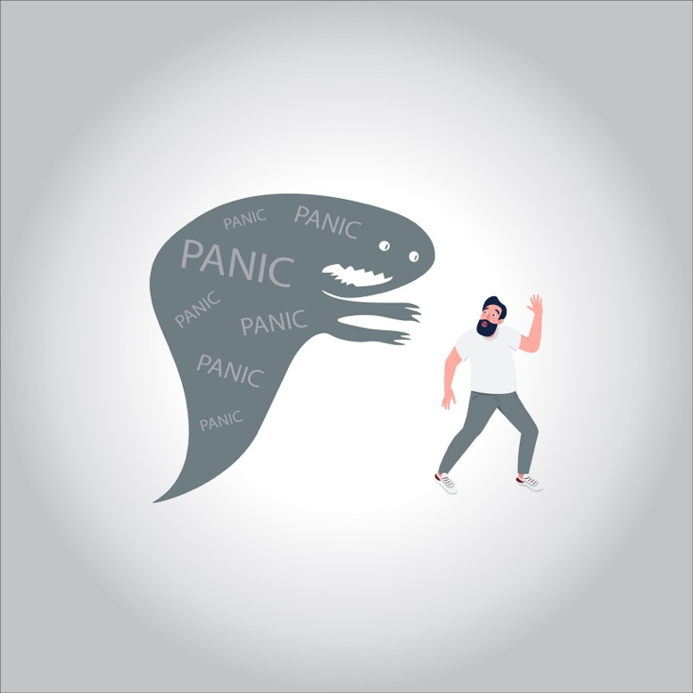

**A panic attack is an intense episode of sudden fear that occurs when there’s no apparent threat or danger. In some cases, you may mistake the symptoms of a panic attack with a heart attack.**

**You might experience a single panic attack. Or you might have multiple panic attacks throughout your life. If left untreated, recurrent panic attacks — and the fear of experiencing them — may lead you to avoid other people or public places. This may be a sign that you’ve developed a panic disorder.**

**What are the symptoms of a panic attack?**

**Panic attacks trigger your sympathetic nervous system. This leads to the “fight or flight” response that you experience when faced with danger.**

**A panic attack can occur suddenly and without warning. Its symptoms may come on gradually and peak after about ten minutes. They may include one or more of the following:**

* **chest pain**
* **difficulty swallowing**
* **difficulty breathing**
* **shortness of breath**
* **hyperventilating**
* **rapid heartbeat**
* **feeling faint**
* **hot flashes**
* **chills**
* **shaking**
* **sweating**
* **nausea**
* **stomach pain**
* **tingling or numbness**
* **feeling that death is imminent**

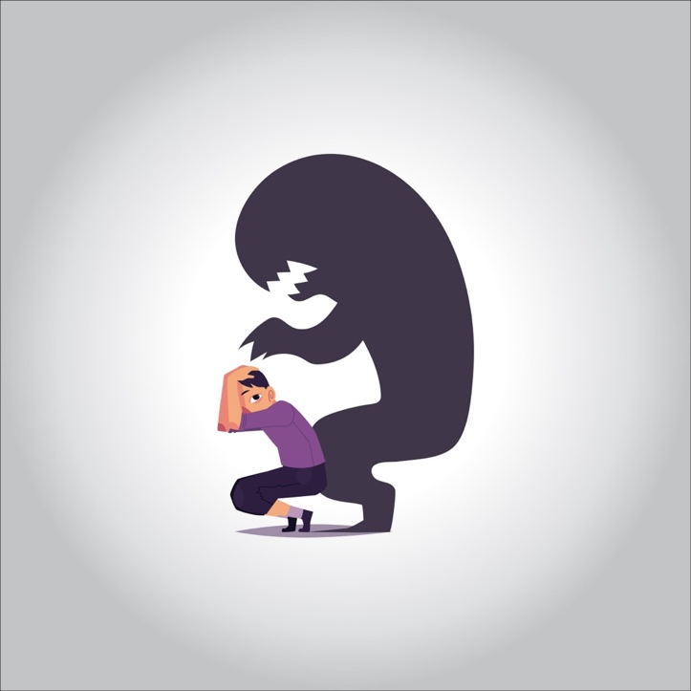

**In some cases, you may develop an overwhelming fear of experiencing another panic attack. This may be a sign that you’ve developed a panic disorder.**

**Panic attacks aren’t life threatening. But their symptoms can be similar to those of other life-threatening health conditions, such as heart attack. If you experience symptoms of a panic attack, seek medical attention right away. It’s important to rule out the possibility that you’re actually having a heart attack.**

**What causes panic attacks?**

**The exact cause of panic attacks is often unknown. In some cases, panic attacks are linked to an underlying mental health condition, such as:**

* **panic disorder**
* **agoraphobia or other phobias**
* **obsessive compulsive disorder (OCD)**
* **post-traumatic stress disorder (PTSD)**
* **generalized anxiety disorder (GAD)**

**Stress can also contribute to panic attacks.**

**Who is at risk of panic attacks?**

**A variety of factors can increase your chances of experiencing a panic attack. These include:**

* **having a family history of panic attacks**
* **having a history of childhood abuse**
* **working or living in a high-stress situation**
* **experiencing a traumatic event, such as a serious car accident**
* **undergoing a major life change, such as having a baby**
* **losing a loved one**

**Living with a mental health condition, such as a phobia or PTSD, can also raise your risk of panic attacks.**

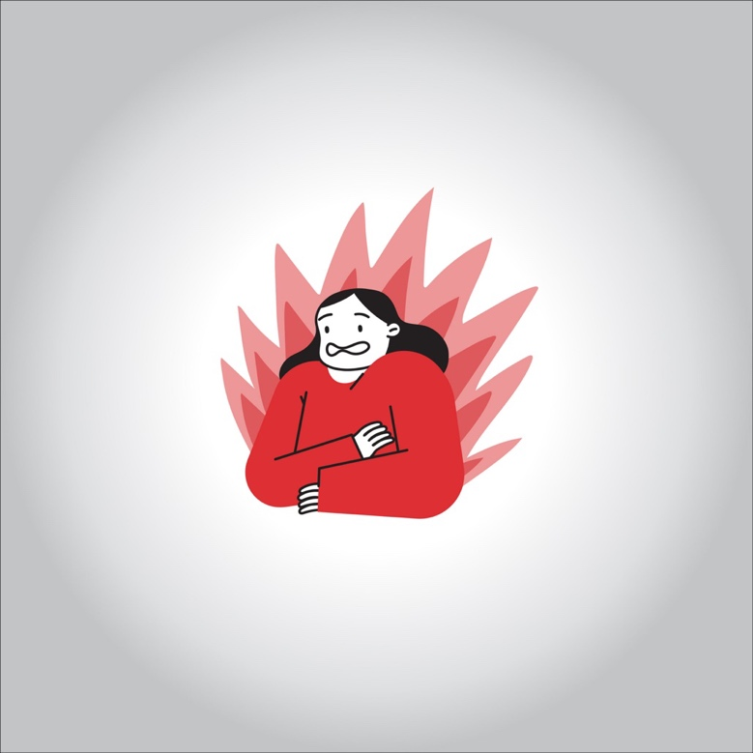

**How are panic attacks diagnosed?**

**To diagnose a panic attack, your doctor will likely ask you about your symptoms and medical history. They may also conduct a physical exam.**

**They may need to conduct tests to rule out a heart attack. They will likely use an electrocardiogram (EKG) to measure the electric function of your heart. They may also recommend blood tests to check your levels of thyroid hormones. A hormonal imbalance can affect your body’s ability to regulate your heart rhythms.**

**If they suspect that you have a panic disorder or other mental health condition, your doctor may refer you to a mental health specialist. You may have a panic disorder if you:**

* **experience frequent panic attacks**
* **develop a persistent fear of experiencing another panic attack**
* **change your lifestyle or behavior due to your fear of experiencing another panic attack**

**How are panic attacks treated?**

**If your doctor suspects that your panic attacks are linked to an underlying mental health condition, you may be referred to a mental health specialist. Depending on your condition, your doctor may recommend a combination of medication, therapy, and lifestyle changes to manage your symptoms.**

**Medications**

* **Your doctor or mental health specialist may recommend one or more of the following medications:**

**Therapy**

**If you have a panic disorder or other mental health condition, your doctor may recommend psychotherapy to help treat it. For example, they may recommend cognitive behavioral therapy. Your therapist will try to address the thoughts, behaviors, and reactions associated with your panic attacks. This may help reduce your fears and anxieties about them. They may also help “re-train” your brain to better differentiate between real and perceived threats.**

**Attending a support group may also help you manage a panic disorder. It can help you develop positive coping mechanisms for dealing with fear, anxiety, and stress.**

**Lifestyle changes**

**Taking steps to reduce stress and improve your overall health may help reduce the incidence of panic attacks. For example, getting plenty of sleep and staying physically active may help lower your stress levels. Stress management techniques, such as deep breathing or progressive muscle relaxation, may also help. It’s also important to avoid or limit your consumption of alcohol, caffeine, and illegal drugs.**

**What is the outlook for panic attacks?**

**If left untreated, recurrent panic attacks may lead you to:**

* **feel anxiety when you think about the possibility of another panic attack**
* **avoid other people or public places for fear of experiencing a panic attack**
* **develop agoraphobia, an intense fear of being in public places**

**To avoid these complications, it’s important to seek treatment for panic attacks.**

**How can panic attacks be prevented?**

**Most panic attacks are unpredictable. As a result, preventing them can be challenging.**

**But you can take some steps to enhance your overall well-being and lower your risk of panic attacks. For example, it’s important to lead an overall healthy lifestyle by:**

* **eating a well-balanced diet**
* **exercising regularly**
* **getting enough sleep**
* **taking steps to reduce stress**

**It’s also important to seek help from your doctor if you experience a panic attack. Getting treatment may help you avoid more panic attacks in the future.**